Beer tender

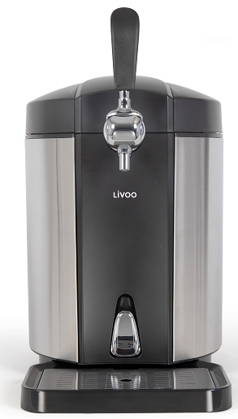

Référence : DOM463
Version : 1.6
Langue : English

Thank you for purchasing a LIVOO product. We pay great attention to the design, ergonomics and user-friendliness of our products. We hope that you will be satisfied with this product.
This instruction manual is available too on our website www.livoo.fr
GENERAL INSTRUCTIONS

PLEASE, TAKE TIME TO READ WELL THE INSTRUCTIONS FOR USE PARTICULARLY BEFORE THE FIRST USE.
A misuse of the appliance can damage it or hurt the user. Assure that you use the appliance for the use for which it is designed; we refuse any responsibilities as for the damages by an incorrect use or a bad manipulation.

- When the device is not in use, swich off the dispenser and always disconnect the plug from the main socket!
- Before using the dispenser, read the operating instructions carefully. Keep the device away from sources of heat, direct sunlight.
- This appliance can be used by children aged from 8 years and above and persons with reduced physical, sensory or mental capabilities or lack of experience and knowledge if they have been given supervision or instruction concerning use of the appliance in a safe way and understand the hazards involved.
- Children shall not play with the appliance.
- Cleaning and user maintenance shall not be made by children without supervision.
- It is absolutely necessary to keep this appliance clean at all times as it comes into direct contact with food.
- Regarding the instructions for cleaning surfaces in contact with food, thanks to refer to the below paragraph “cleaning” in the manual.
- Only use original accessories. When transporting the beer dispenser, always carry it holding the bottom edge and not by the beer tap, lid or power cord.
- Only use the dispenser with the correct beer keg. Do not attempt to change or repair the dispenser, if you have any problems or difficulties, to protect yourself safety, please contact to our customer service. It may lead electric shock if fit or repair by youself. Please refer to our offical service department , otherwise we take no responsibility.
- Keep packaging out of the reach of children(danger of suffocation). Keep the dispenser out of the reach of children, as can’t recognize the danger of electrical appliance.
- Regularly check the dispenser and cable for damage. Do not use the appliance if it is damaged.
- Ensure your standard power supply comply with the technical data.
- Only use the parts match with the device or recommend by the local dealer.
- Do not squeeze or bend cable, do not connect with any heating.
- Ensure do not trip the cable.
- Do not put the dispenser on the gas container or near electric cooking appliance. Keep away from inflammables.
- If the dispenser can’t work or damaged, unplug it immediately.
- When remove the plug from the socket, do not pull the plug out by the cable.
- The dispenser is not suitable for outdoor use.
- Do not sit or stand on the dispenser.
- Do not place glasswork on the lid.
- Do not place any objects in the air vents.
- Disconnect the power cable from the power supply before cleaning, maintenance and assembly of accessories without supervision.
- The appliance must not be immersed in water.
- Ensure that ventilation openings are kept clean and unobstructed.
- Only use this dispenser when the temperature is 22-24℃.
- Do not use leaked or damaged keg.
- The appliance is not intended to be operated by means of external timer or separate remote control system.
- If the power cord is damaged, it must be replaced by the manufacturer, its service or similarly qualified persons in order to avoid a hazard. (*)
- WARNING: when positioning the appliance, ensure the supply cord is not trapped or damaged.
- WARNING: Do not locate multiple portable socket-outlets or portable power supplies at the rear of the appliance.
- Do not store explosive substances such as aerosol cans with a flammable propellant in this appliance.
- Ensure that the refrigerant circuit remains undamaged.
- Caution: There is a risk of injury from improper use.
- Appliances which use flammable insulation blowing gases, instructions shall include information regarding disposal of the appliance.
- Clean regularly surfaces that can come in contact with food and accessible drainage systems.
- The heating element surface is subject to residual heat after use.
- Opening the door for long periods can cause a significant increase of the temperature in the compartments of the appliance.
- This appliance is intended to be used in household and similar applications such as:
- staff kitchen areas in shops, offices and other
working environments
- farm houses
- by clients in hotels, motels and other
residential type environments
- bed and breakfast type environments

^{(*)} Competent qualified electrician: after sales department of the producer or importer or any person who is qualified, approved and competent to perform this kind of repairs in order to avoid all danger. In any case you should return the appliance to this electrician.

TECHNICAL DATA
Compatible with 5 L Heineken kegs
Descriptions | Specification
Technical informations | AC 220V- 240V 50Hz  65 W
Available capacity | 5 liter beer keg
Insulation gas | Cyclopentane
Refrigeration performance | Minimum temperature from 3 to 6 °C  With ambient temperature from 22 to 24 °C
Noise level | ≤45dB(A)
Dimensions (mm) | L460 x W275 x H475
Net weight | 5.2kg
Aluminium radiator system | √
Semi-conductor cooling technology | √
Manual drainage outfit | √
Cool preservation system | PU insulation / Weight 300±5g
Climate type | N/SN
Class II/Double insulation for extra protection of the appliance. | 

Description

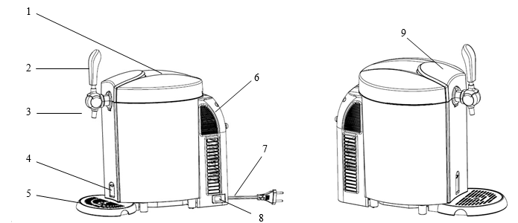

- Top cover
- Tap handle
- Tap
- Drain switch
- Deep tray
- Rear cover
- Power cord
- On/off switch
- Door lock button

USE
- Put the beer cooler on a horizontal and stable surface.
Note: Should leave at least 10cm free space behind and on both sides of the beer cooler for the best use. And do not block the opening of ventilation of the appliance to avoid any overheating.
- Install the tap handle on the tap, make sure both end fit together perfectly.
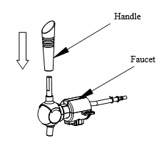
- Install the drip tray.
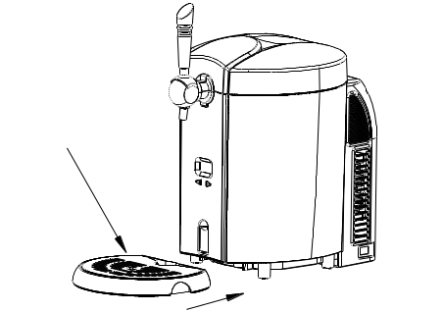
- Open the beer cooler by pressing down the top cover. Put 800 ml water into the cooling cavity or to the max level. The beer cooler can also work without water.
Note: Make sure the drain switch is at “Off” position, and no extra objects in the cooling cavity.
Drain switch is closed
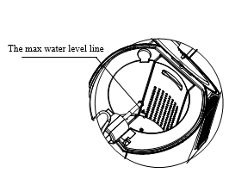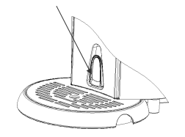
Your appliance is compatible with Heineken kegs. They are pre-charged with CO2, and do not require the use of regulator, no need to install the CO2 unit.
- The Heineken connector provided with your beer cooler is compatible with all Heineken 5 liters kegs. However to use it : you must remove the green base from the keg in order to install the new adaptor, provided with the beer cooler.
- Place the ready-to-use keg in the cooling cavity of the appliance, connect the inlet hose to the keg.
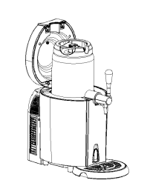
- When setting the new connector to the Heineken keg,
- you must firstly install the clear beer tube one side to the adaptor, one end to the tap mechanism
- then install the adaptor to the Heineken keg. Make sure that the adaptor is well connected to the valve of the keg.

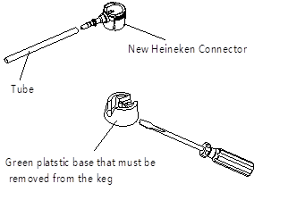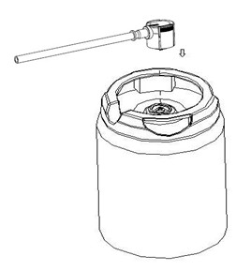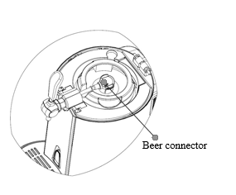

- Close top cover.
- Plug in and turn on the beer cooler.
- It will take 19-21 hours to cool the beer to 2-6℃at 22-24 ℃ ambient temperature. We recommend you to cool your beer kegs in the fridge first for 12hrs. After this, you can insert your keg into the cooling cavity.
The highest the ambient temperature is, the longer time you will need to cool your keg.
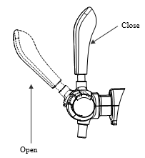
- To pour the beer out : lean your beer glass against the tap spout, slowly pulling down the tap handle then fully open the tap handle to balance the foam.
Note : we recommend you to fill half of the glass, have a break and pour the rest. Also never immerse the tap spout into the beer glass
It is normal to have more bubbles when pouring the first 3 cup of beer. There will be a sharp and high-speed jet when pouring the last cup of beer from keg.
REPLACE WATER INSIDE THE COOLING CAVITY
We recommend to replace the water inside the cooling cavity every week.
External view
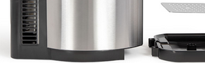
below seen from the inside, here are the steps to follow:
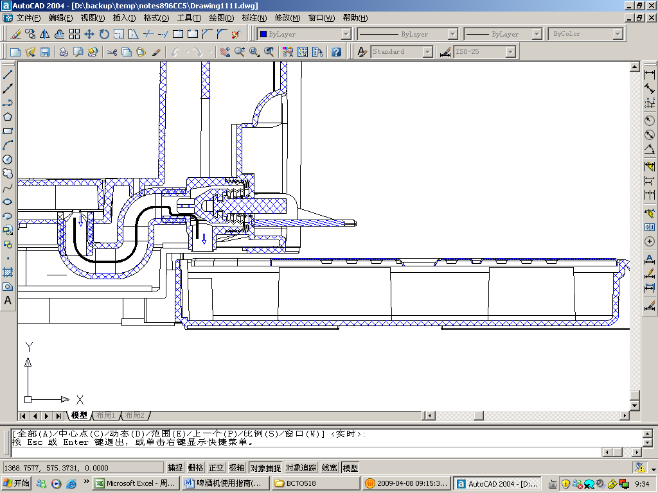
Open the drain switch, water flows into the S shape drainpipe
Move the drain switch to horizontal line, will start to drain water

Drip tray

Water flows into drip dray

- Open the drain switch to drain out the water from the cooling cavity into the drip tray. Make sure the drip tray is well set into the notch to avoid any water flowing out on table or surface.
Important: the drip tray can load 450ml water. So you need to repeat the operation twice.
- After all water drain out, close the drain switch and put 800ml fresh water into the cavity.
ACCESSORIES INCLUDED WITH YOUR BEER COOLER

No. | Name | Qty. | Picture
1 | Beer tube | 2 | 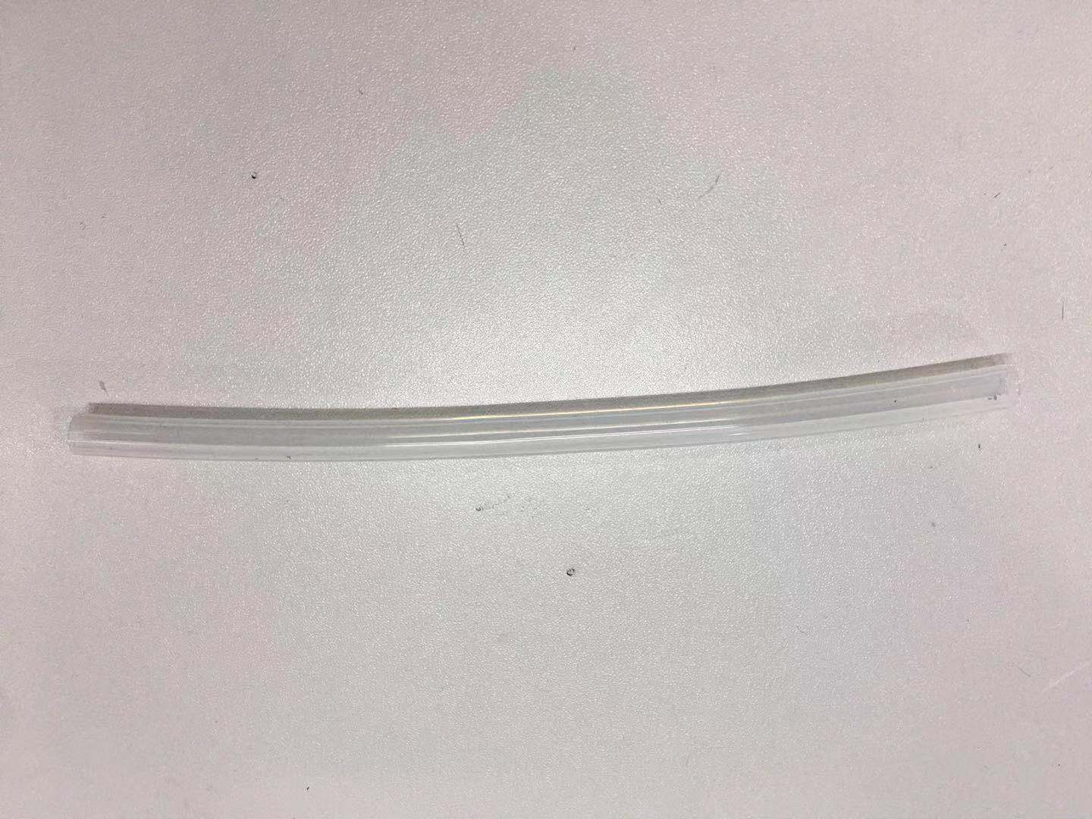
2 | Heineken adaptor | 3 | 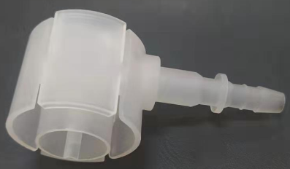
3 | Cleaning bottle | 1 | 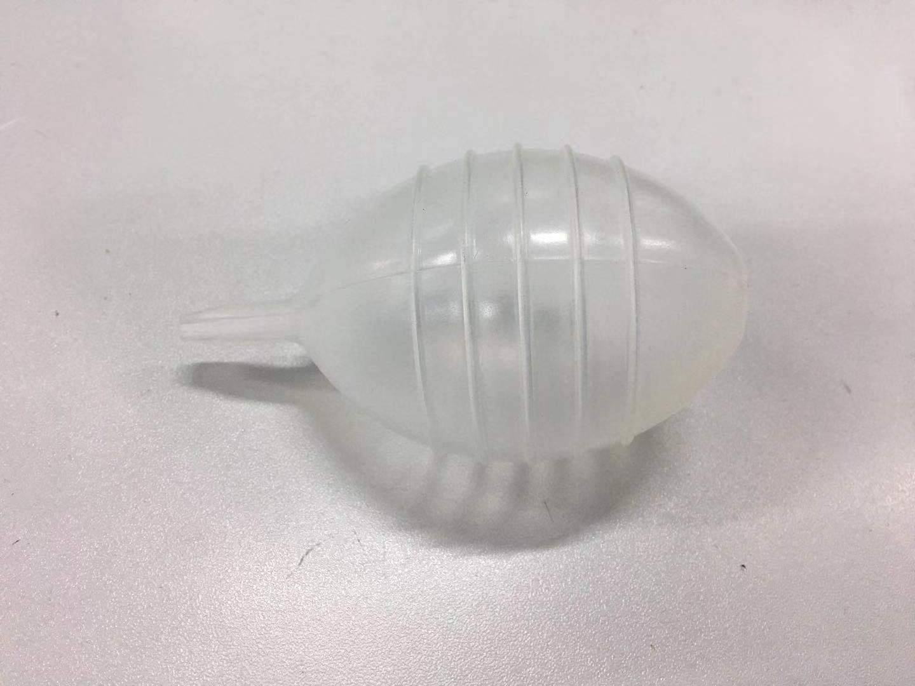

CLEANING AND STORAGE
The beer cooler requires clean before the first use or if not used for long time.
Clean the whole machine with dry cloth. Otherwise two cleaning way is recommend as following
- Load warm water into the cleaning bottle.
- Connect the end of piercing pin, press the water into the pin to clean the pin tube and push the water out from the beer tube at the other end.
- Repeat these cleaning steps until the beer tube is cleaned. It needs 3 bottles warm water at least.
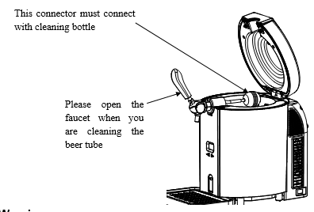
Never put the tap mechanism parts in the washing machine or dishwasher.
Never use the chemical cleaning detergent to clean the parts, warm or purified water is recommended.
TO CHANGE BEER TUBE
Please replace the beer tube if it is damaged and causes beer leakage.
- Remove the cap by pressing the switch below the throat clamp.
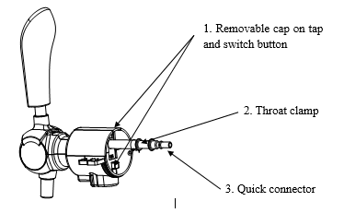
- Pulling down the tap handle until it is full open and keep it opened this way.
- Draw out the tube from the tap and pull down the connection and tube.
- Replace the tube by a new beer tube and install the beer tube according to above steps, in reverse procedure.
NOTES: Do not move other screws when processing tube replacement, otherwise, it may cause the beer leakage or gas leakage.

MAINTENANCE
You can check the Troubleshooting Guide. It gathers causes of minor operation problems that you can correct by yourself.
Trouble | Cause | Troubleshooting
The tap does not work / can’t pour beer out | 1. The pouring tube is not well set in the adaptor  2. No beer in the keg | 1. Check and connect the tube to the adaptor  2. Change a new keg
Too much foam pouring out | 1. Use a wrong way to pour beer out  2. The beer temp is high (better at 3-5°C)  3. The keg is shaken before usage  4. Almost no beer in the keg | 1. Use the right way to pour beer out  2. Cool the beer down to 3-5°C  3. Put the beer keg aside a while until no bubble inside  4. Change a new keg
Beer flows out too slowly | 1. There's not much beer left. There's low air pressure in the barrel | 1. Change a new keg

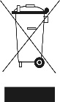
Correct disposal of the unit
(Electrical and Electronic Equipment)
(Applicable in the European Union and the rest of Europe that have adopted separate collection systems countries)
The European Directive 2012/19/EU on Waste Electrical and Electronic Equipment (WEEE), requires that old household electrical appliances must not be disposed of in the normal household waste stream.
Old appliances must be collected separately in order to optimize the recovery and recycling of the materials they contain and reduce the impact on human health and the environment.
The symbol of the crossed out dustbin is marked on all products to remind the obligations of separate collection.
Consumers should contact their local authority or retailer for information concerning the correct disposal of their product.


LIVOO
BP 61071
67452 Mundolsheim

